**INTERNATIONAL STUDENTS CREDIT CARD SYSTEMS**

AKSHAYENDRA NATH SANAM VENKATA – (Z1936788)

**OMIS 651: Business System Analysis & Design**

**Prof. Tim Schwartz**

December 07, 2021

**Step 1:**

**1.1 Introduction:**

International students in the United States are unable to get a credit card since they do not have a Social Security number. Obtaining a Social Security Number is not an easy process. Yet without one, we will be unable to apply for a credit card in the future. The same as in other countries, they have their own set of cards, such as the India-Pan Card or the Australia-TRV Card, that enable them to apply for credit cards in their home country. In order to address this problem, we would want to suggest a new technological solution.

**1.2 Proposed Solution**

The technology that is being created will assist Global Bank in a variety of activities. For example, when an applicant submits an application for a credit card, the global bank will have the ability to access the applicant's credit card profile. It will also enable the Global bank to validate the card information that is sent in via the system as well. When the application review process is completed, this system will also enable the bank to accept or refuse the application, and the confirmation will be sent to the prospective customer.

Our proposed system we are going to built using In house resources. In-house resources could be included current personnel, including ourselves. We are allowed to assign one or more of our team members to work on a task or project when we manage it in-house. Which will help us learn the system functionality more clearly and maintain them when necessary. Moreover, we can set our schedule as we want based on project improvements. In addition, it’ll reduce the cost as well. On the other hand, outsourcing we’ll have to hire someone from outside which could be costly.

**1.3 Business Statement:**

The Proposed System will provide necessary solutions to make the process of obtaining credit cards easier, the international students are among the ones who will be benefited by the implementation of this system.

**1.4 Project Requirements**

**1.4.1 Functional Requirements**

* The applicants shall be able to create an application through the system.
* The applicants shall be able to receive the confirmation email through the system.
* Global bank shall be able to access everyone’s credit card profile through the system
* Global bank shall be able to confirm the application.
* Global bank shall be able to reject the application.
* Global bank shall be able to send confirmation email through the system

**1.4.2 Non-Functional Requirements**

• System should be scalable and secured

• System should be user friendly to manage.

• System should provide a rich and easy to use experience

**Why credit card encryption needed:**

Putting credit card encryption in place reduces the likelihood of private and valuable card information being stolen significantly. These measures apply to the card itself, as well as the terminal where a credit or debit card is scanned, and the transmission of information between that terminal and its network's back end. This is accomplished through the use of encryption or tokenization. With more than 46 percent of Americans having been victims of fraudulent activities in the last five years, it is becoming increasingly critical to safeguard our financial accounts and personal information. For our system we are using standard encryption method to encrypt credit card information, there are two sets of code available in backend and frontend, frontend sends encrypted credit card number with base64 encryption and with the custom encryption key backend is able to decrypt it in order to perform operations.

**How proposed system is user friendly:**

The Ui design is made with user experience in mind, the UI is made easy to understand for the user following the concept of user experience. This particular system focuses a lot on information gathering so the forms required to gather this information are put in place so that users can understand what exactly is going on and what’s need to be put in the form. Multiple clues given for the insertion points in the form which helps user understand better. Which could be possible to done quickly and easily. Since applicants will have to fill up the application form through system which has to be fast and quick. Therefore, this makes our proposed system more user friendly. Moreover, our proposed system is user friendly the customer will use the system more confidently.

**1.4.2: Technical Requirements**

**For Mobile Application Development**

• Elegant Graphic Designing of Application

• UI/UX Works

• Complete development of Web application & Web Portal • API’s Integration

• Quality Assurance Testing & User Acceptance Testing

• User Friendly

**1.4.3: Report/ Monitoring Methods**

• Weekly Status report will be sent to client via email

• Communication via Skype/email/meeting in person as per the requirement

**1.5 Proposed Technology**

**Framework:** ReactJS

**RDBMS:** MySQL

**Presentation & Layout:** HTML 5 and Bootstrap for web **Web Services:** All the web services will be written in Codeigniter (CI) and NodeJS

**1.6 Timeframe**

To complete the work outlined in the project scope, we'll need approximately 5-6 weeks from beginning to end for both parts, depending on when we receive feedback at each milestone. Upon signing the proposal, we are prepared to start work immediately.

**Development Phrases**

|  |
| --- |
| Kick-off meeting  Graphics designs Modification  API Development  Web App Development  Web Services Integration  QA Testing  Go-live |
|  |
|  |

**1.7 Methodology & Approach (Scrum)**

Scrum is an agile project management technique that is often used in software development. Agile software development using Scrum is sometimes misunderstood as a technique; however, instead of considering Scrum as a methodology, consider it as a framework for managing a process. Following are the ways we will approach this project with Scrum Methodology. Figure 1.1 shows the diagram of Scrum methodology.

**Figure 1.1:** Diagram of Scrum methodology

All of these steps is described below and explained how the system will follow scrum methodology to complete the entire project.

* Develop a modular framework with loosely linked components that allows for alteration of any component without impacting other components - this would allow for the inclusion of new features and the reuse of current components. For instance, client-server communication may be built in such a way that it is independent of the kind of requests (for various types of transactions) made by the client. Additionally, this would enable the separation of business logic (which is static in nature) and configuration data (dynamic, would be different for different merchants).
* Each component should offer an abstract interface that other components may communicate with — this would enable simple modification for various merchant kinds or support for numerous connection modes, such as dial-up, IP, or wireless.
* As a financial application, accuracy and security are critical to the project's success. To ensure this, rigorous unit and system testing will be conducted. Before sensitive data is stored on the server, it is encrypted.
* The application should be cross-platform.
* The application should have a mechanism for the server to initiate remote software upgrades.
* The project would be transparently conducted — the customer would provide input twice a week. The application would be hosted on our server throughout development, allowing for early evaluation and input from the customer.

**1.8 Security Implementation**

Typically, security implementation is determined by the data's sensitivity and, of course, corporate compliance. While the implementation, when conceived and implemented correctly, does assure data safety, it often comes at a cost – for example, increased data processing speed, or in other words, application response time.

* The following security features may be included in such a deployment, but are not limited to:
* Implementation of a password management system for establishing, managing, and updating passwords
* Establish rules to protect the facility and its equipment against unlawful physical entry, modification, or theft.
* Data storage and backup procedures that are adequate
* Implementation of authentication and permission for access to sensitive information.
* Terminate the session when a predefined amount of time has passed with no activity.
* Encrypt data whenever possible (both over the network and inside the application).

**2.0 Step 2:**

**2.1 Use Case Diagram and Analysis**

The system use case diagram consists of six use cases and they are to access applicant’s credit card profile, confirm application, reject application, send confirmation email, receive confirmation email and create an application. All of these functionalities will be accessed by 2 actors which are global banks and applicants.

The proposed system is all about providing an opportunity for international students in order to get credit cards in foreign countries. To do that, the applicant must apply for an application through the system. That's why we need to create an application use case. Once the applicant’s done with the application, the global bank will access their previous credit card profile and verify. If they find the person is validated and eligible for the credit card based on their previous records, then they’ll send a confirmation email to the applicant. And meantime, if applicants found as fraud or non-eligible, they will receive a rejection email through the system. Therefore, we can say that all of the use cases are performing vital rules in order to complete each of the functionality of the system. Figure 2.1 shows the use case diagram of the system.

**Figure 2.1 :** System use case diagram

**2.2 DFD 0 and DFD 1**

Figure 2.2 shows the DFD 0 which is also known as a context diagram. Figure 2.3 shows the DFD1 of the proposed system. Which highlights the main objectives of the system and breakdown the high-level process of 0-level DFD into subprocesses.

The aim of both of these diagrams is to show the boundaries and scope of the whole system. It helps to understand how a person communicates with the system. Hence, to understand system boundaries and understand the system it is very essential to have a DFD 0 and DFD 1 diagram.

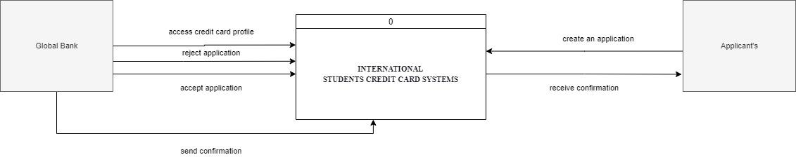

**Figure 2.2:**  DFD 0 of the proposed system.

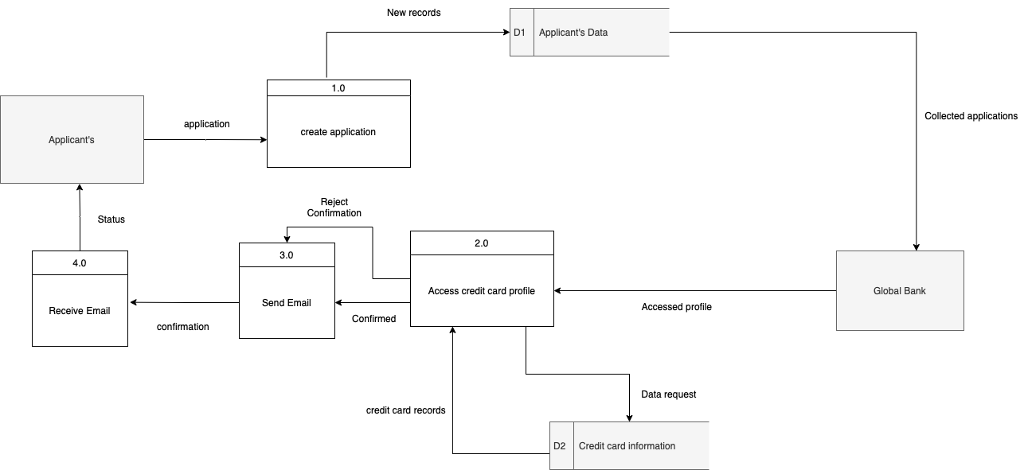

**Figure 2.3**: DFD1 of the proposed system

**2.3 How the current system works and how the proposed system will function using these diagrams**

The Functionality of the Current System is done manually, with the help of an SSN card they apply for the Credit Card, but this system automatically disables international students from applying for credit card. To tackle in Figure 2.3, we can see that our system uses an online system where users can directly apply for credit cards. The global bank can easily access the credit card profile of the user and confirm or deny the credit card to the applicant. The applicant will automatically receive an email with the status of their application from the system once the process is completed.

**2.4 ERD of the proposed system**

Figure 2.4 shows the ERD (Entity Relationship Diagram) of the system. The diagram consists of 4 entities such as applicant, profile information, application and application status. Each entity/table will store different data, since all tables contain different attributes. Each of the tables is connected with each other through foreign keys. Moreover, the ERD also shows the cardinality between the entities. For instance, each applicant may have only one profile information at a time and so on.

The applicant table will store the data of the applicant’s information. The profile information table will contain the details of the credit card profile of an applicant. An application table will contain the data of application details. Finally, application status will help to show which application is accepted and rejected. In addition, this table will contain a detailed description why the application got rejected and accepted.

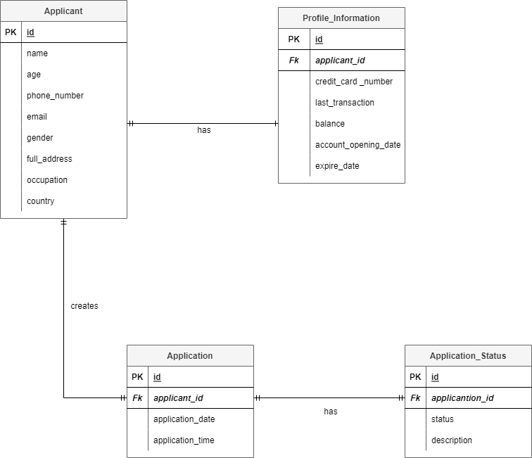

**Figure 2.4:**  ERD (Entity Relationship Diagram) of the proposed system

Test plan

**2.5 System Test Cases:**

Testing is a very essential part before deploying a system. Testing will be performed once the system is developed. Through the testing plan, the user will input the test data and check the expected outcome. During testing if any bug or error was found the developer would get a chance to fix the problem before deployment of the system. For the proposed system, black box testing is performed during the development which is part of UAT (user acceptance testing. Basically, user acceptance testing is conducted by the tester. For testing purpose it’ll take one week of UAT testing. We will have a UAT deployment every day during that week.

**Below table shows the Test plan details of the proposed system:**

|  |  |  |  |  |  |  |  |
| --- | --- | --- | --- | --- | --- | --- | --- |
| Test Case Number | Feature needs to be tested | Feature not to be tested | Test/example | Person who will test | Expected result | Item/pass | Time of testing before go live |
| TC001 | Access everyone’s credit card profile | - | Go to access credit card profile page and fill up all required filled and click on access credit card profile | A | Global bank will successfully access everyone’s credit card profile |  | 1 week |
| TC002 | Reject application | - | Go to accept and reject page. Select applicants and click on reject button | B | Global bank will successfully reject application |  | 1 week |
| TC003 | Accept Application | - | Go to accept and reject page. Select applicants and click on accept button | C | Global bank will successfully accept application |  | 1 week |
| TC004 | Send confirmation email | - | Go to accept and reject page. Select applicants and click on send confirmation email | D | Global bank will successfully send the confirmation email |  | 1 week |
| TC005 | Receive confirmation email | - | Applicant receives the email | E | Applicant’s will successfully receive the confirmation email |  | 1 week |
| TC006 | Create an application | - | Go to applicant’s page. Click on create an application | F | Applicant’s will successfully create an application |  | 1 week |

**Step 3: Wireframe of user interface**

**Overall designs:**

|  |
| --- |
|  |

**Create an application page:**

|  |
| --- |
|  |

**Access credit card profile page:**

|  |
| --- |
|  |

**Accepted/ Rejected and send confirmation page:**

|  |
| --- |
|  |